**2021 BOTANY — HONOURS**

**Paper : DSE-B-8 (Natural Resource Management)**

**Full Marks : 50**

**The figures in the margin indicate full marks. Candidates are required to give their answers in their own words as far as practicable**

**1. Answer any five questions : 2×5**

**(a) Distinguish between agricultural and pastoral land.**

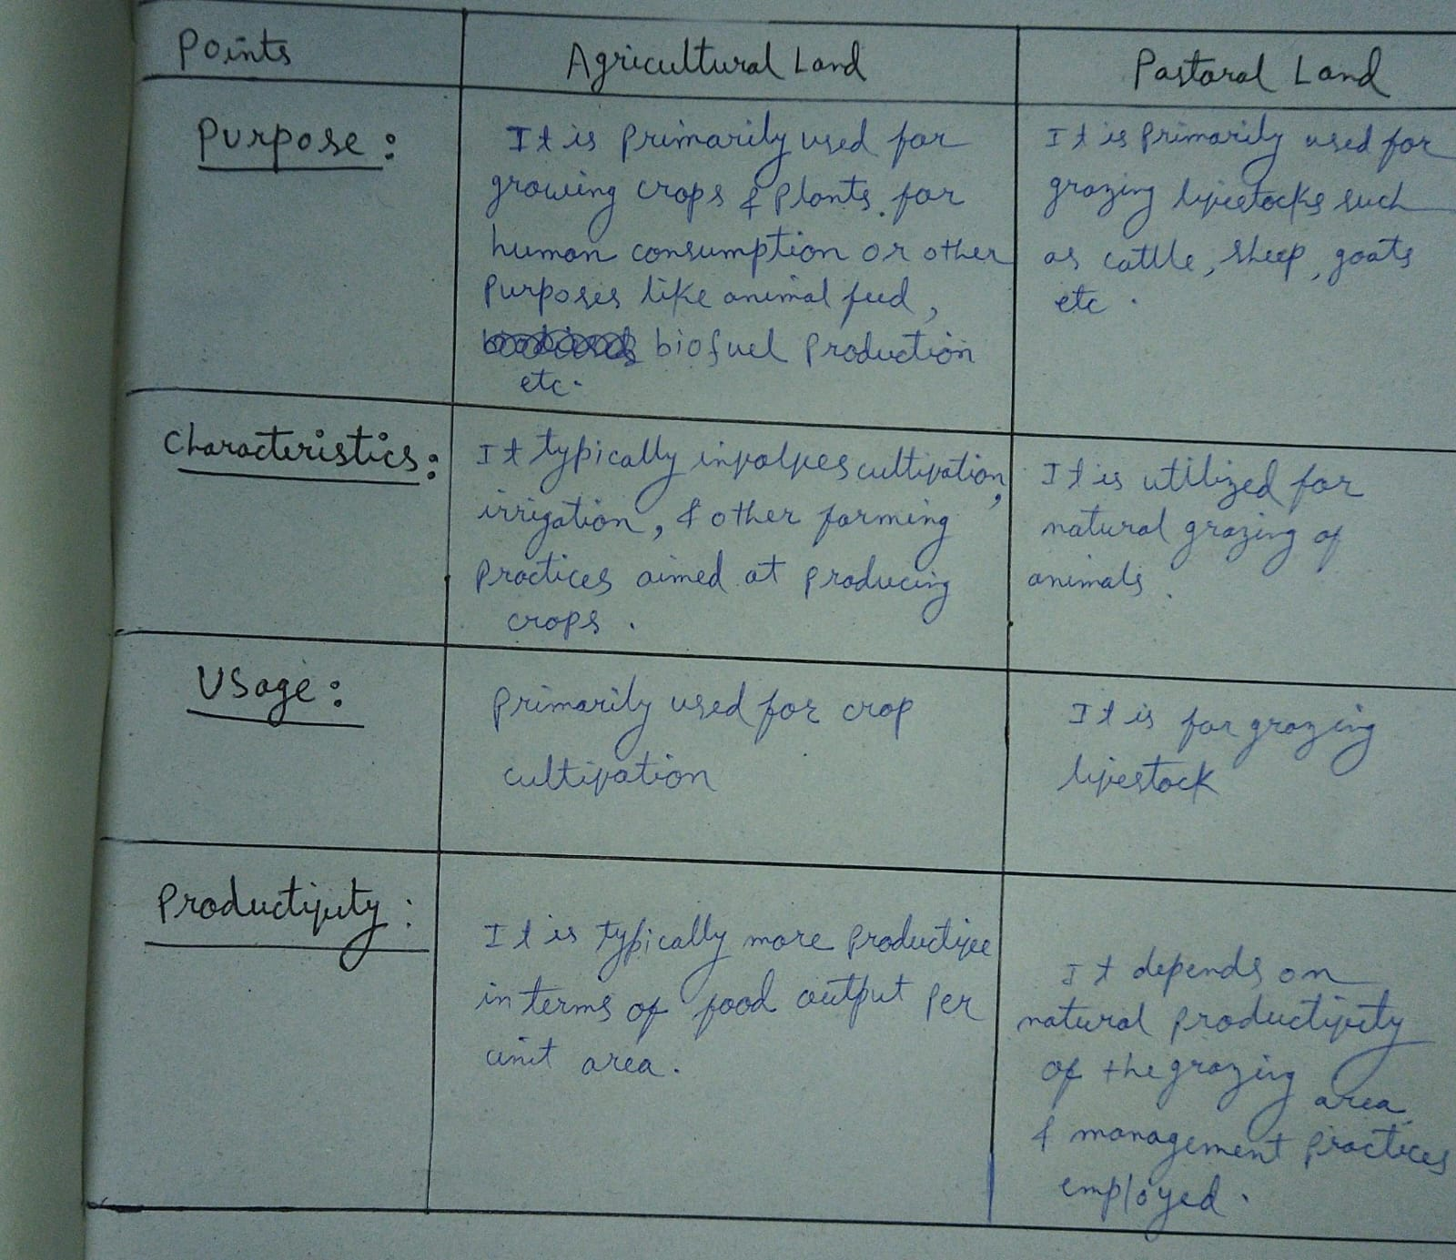

**(b) What do you mean by bioprospecting?**

Bioprospecting is the search for valuable biological resources in nature, like plants or microorganisms, to find compounds or genes that can be used in various industries. It involves collecting samples, analyzing them for potential applications, and developing commercial products based on the discoveries. Ethical and legal considerations, including fair benefit-sharing and biodiversity conservation, are important aspects of bioprospecting.

**(c) Write the full form of IUCN. State one major objective of IUCN.**

The full form of IUCN is the International Union for Conservation of Nature.

One major objective of IUCN is to promote the conservation and sustainable use of biodiversity.

**(d) Mention the important criteria for the progress in economic sustainability**.

**Economic sustainability** involves evaluating economic activities in a way that ensures long-term viability while considering environmental and social impacts. Here are some important criteria for achieving economic sustainability:

1. **Balance in International Trade**: A sustainable economy maintains a healthy balance in international trade. This means promoting exports while avoiding excessive reliance on imports.
2. **Price Stability**: Economic stability requires maintaining a stable overall price level. Controlling inflation and deflation helps create an environment conducive to sustainable growth.
3. **Equal Income Distribution**: Ensuring a more equal distribution of income contributes to economic sustainability. Reducing income inequality fosters social cohesion and stability.
4. **Sustainable Debt Levels**: Managing public and private debt is crucial. Sustainable debt levels prevent excessive financial burdens and allow for future investments.

**(e) Distinguish between forest cover and tree cover.**

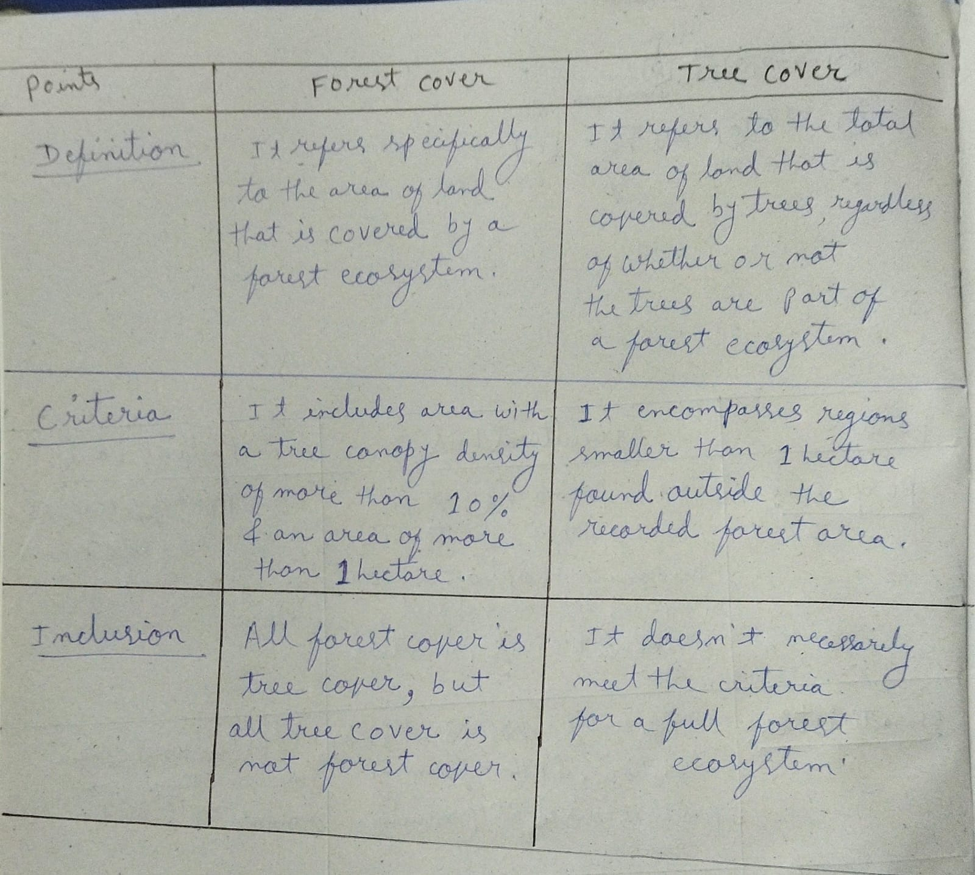

**(f) What are the four Rs used as basic principle of solid waste management?**

**The four Rs used as the basic principles of solid waste management are:**

1. **Reduce**:

- Minimize the amount of waste generated.

- Focus on lowering consumption and avoiding unnecessary purchases.

- Opt for products with minimal packaging and those that are durable and long-lasting.

2. **Reuse**:

- Extend the life of products by using them more than once.

- Find new uses for items instead of discarding them.

- Donate or sell items that are no longer needed but are still usable.

3. **Recycle**:

- Process waste materials to make new products.

- Separate recyclable materials like paper, plastic, glass, and metals from other waste.

- Support and participate in local recycling programs.

4. **Recover**:

- Extract useful materials or energy from waste.

- Implement waste-to-energy processes to convert non-recyclable waste into usable forms of energy.

- Use composting and anaerobic digestion to recover nutrients and organic matter from organic waste.

These principles aim to reduce the environmental impact of waste, conserve natural resources, and promote sustainable waste management practices.

**(g) Define non-renewable resource. Give an example**.

A **non-renewable resource** is a natural resource that cannot be replenished or regenerated on a human timescale once it is depleted. These resources are typically formed over geological timescales of millions of years, and their rate of consumption exceeds their rate of formation. Consequently, they are finite and will eventually be exhausted if used continuously.

**Example**: **Coal** is a classic example of a non-renewable resource. It is formed from the remains of ancient plants and organisms that were buried and subjected to heat and pressure over millions of years. Once the existing coal reserves are mined and used, they cannot be quickly replaced, making coal a non-renewable resource.

**(h) What do you mean by environmental refugees?**

**environmental refugees** are people who are **displaced** due to environmental causes, such as land loss, degradation, and natural disasters. These individuals are forced to leave their homes and communities because the environment can no longer support their livelihoods.

Or//

**Environmental refugees** are people who are forced to leave their homes or regions due to environmental factors that pose a serious threat to their well-being and livelihoods. These factors can include natural disasters, such as floods, hurricanes, and earthquakes, as well as long-term environmental changes, such as desertification, sea-level rise, and climate change.

**2. Answer any two questions :**

**(a) Write short notes on the importance of Agroforestry. 5**

Agroforestry is a type of land management where trees or shrubs are planted around or amid crops or pastureland. This heterogeneity of the agricultural system commences an agroecological succession, similar to that found in natural ecosystems, and so begins a cycle of events that improve the agricultural system’s functioning and sustainability.

Here's a more detailed exploration of the importance of agroforestry:

1. **Biodiversity Conservation**:
   * Agroforestry systems promote biodiversity by providing habitat for a wide range of plant and animal species. The diverse structure of these systems supports a variety of ecological niches, contributing to overall ecosystem resilience.
   * Trees in agroforestry systems often act as "biological corridors," facilitating the movement of wildlife between fragmented habitats and enhancing genetic diversity within populations.
2. **Soil Conservation**:
   * The presence of trees in agroforestry systems helps to prevent soil erosion by reducing the impact of wind and water. Tree roots anchor the soil, stabilizing it and reducing the risk of erosion.
   * The leaf litter and organic matter from trees contribute to soil fertility, improving soil structure and nutrient retention. This results in healthier soils that are more resilient to degradation.
3. **Climate Change Mitigation**:
   * Trees in agroforestry systems play a crucial role in mitigating climate change by sequestering carbon dioxide from the atmosphere through photosynthesis. This helps to reduce greenhouse gas concentrations in the atmosphere, mitigating the impacts of climate change.
   * Agroforestry practices such as alley cropping and silvopasture can sequester significant amounts of carbon in both above-ground biomass and soil organic matter, making them valuable tools for climate change mitigation.
4. **Sustainable Land Use**:
   * Agroforestry optimizes land use by combining different land uses within the same area. By integrating trees with agricultural crops and/or livestock, agroforestry systems make more efficient use of available resources such as sunlight, water, and nutrients.
   * This integrated approach to land use maximizes productivity and diversity while minimizing negative environmental impacts, making agroforestry a sustainable alternative to conventional agricultural practices.
5. **Economic Benefits**:
   * Agroforestry diversifies income sources for farmers by providing multiple products such as timber, fruits, nuts, fodder, and medicinal plants. This diversification reduces the reliance on a single crop or commodity, enhancing resilience to market fluctuations.
   * Trees in agroforestry systems can also provide valuable ecosystem services such as shade, windbreaks, and erosion control, further enhancing the economic value of these systems.
6. **Food Security**:
   * Agroforestry systems contribute to food security by providing a continuous supply of diverse food products throughout the year. This includes fruits, nuts, vegetables, and fodder for livestock, which can supplement household diets and improve nutritional outcomes.
   * The diversity of crops and tree species in agroforestry systems helps to buffer against the impacts of pests, diseases, and climate variability, reducing the risk of crop failure and food shortages.
7. **Water Management**:
   * Trees in agroforestry systems play a critical role in water management by improving groundwater recharge, reducing waterlogging, and increasing water retention in the soil. The presence of trees helps to regulate water cycles, mitigating the impacts of floods and droughts.
   * Agroforestry practices such as riparian buffers and agroforestry in watershed areas can also help to protect water quality by filtering pollutants and reducing sedimentation in rivers and streams.
8. **Livelihood Improvement**:
   * Agroforestry creates employment opportunities and enhances livelihoods, particularly for small-scale farmers and rural communities. By diversifying income sources and increasing agricultural productivity, agroforestry can improve standards of living and reduce poverty.
   * In addition to direct economic benefits, agroforestry can also provide social and cultural benefits by strengthening community ties and preserving traditional knowledge and practices related to land management and agroecology.

In summary, agroforestry is a multifunctional land management approach that offers a wide range of benefits for the environment, society, and economy. By harnessing the synergies between trees, crops, and livestock, agroforestry systems contribute to biodiversity conservation, soil conservation, climate change mitigation, sustainable land use, economic development, food security, water management, and livelihood improvement. As such, agroforestry has the potential to play a significant role in sustainable development efforts worldwide.

**OR//**

the **importance of agroforestry** in more detail:

1. **Biodiversity Conservation**:
   * Agroforestry systems promote biodiversity by integrating trees, crops, and livestock. The diverse plant species provide habitats for various animals, insects, and microorganisms.
   * Biodiversity enhances ecosystem resilience, pollination, and pest control. It also contributes to genetic diversity, which is crucial for adapting to changing environmental conditions.
2. **Soil Health and Fertility**:
   * Trees in agroforestry systems contribute organic matter to the soil through leaf litter and root decomposition.
   * Their deep roots help prevent soil erosion and improve soil structure.
   * Nitrogen-fixing trees (such as legumes) enhance soil fertility by fixing atmospheric nitrogen.
3. **Carbon Sequestration and Climate Mitigation**:
   * Trees sequester carbon dioxide through photosynthesis, storing carbon in their biomass and soil.
   * Agroforestry practices contribute to climate change mitigation by reducing greenhouse gas emissions.
   * Carbon storage in agroforestry systems can be substantial, especially in perennial tree crops.
4. **Improved Crop Yields and Resilience**:
   * Agroforestry provides shade, windbreaks, and microclimates that benefit crops.
   * Intercropping with trees can enhance crop yields by optimizing resource use (e.g., light, water, nutrients).
   * Diverse agroforestry systems are more resilient to pests, diseases, and extreme weather events.
5. **Economic Benefits**:
   * Agroforestry generates income from multiple sources: timber, fruits, nuts, fodder, and medicinal plants.
   * It diversifies livelihoods, reducing dependence on a single crop.
   * Farmers can sell surplus products, contributing to local economies.
6. **Water Management**:
   * Trees help regulate water flow, prevent soil erosion, and recharge groundwater.
   * Agroforestry reduces water runoff and enhances water availability for crops.
7. **Community and Cultural Values**:
   * Agroforestry practices often align with local traditions, knowledge, and cultural values.
   * They strengthen community ties and promote sustainable land use.

In summary, agroforestry is a holistic approach that balances ecological, economic, and social aspects, leading to sustainable land management and improved livelihoods.

**(b) What is EIA? Briefly state the importance of EIA on biodiversity conservation. 1+4**

**Environmental Impact Assessment (EIA)** is a crucial tool used to evaluate the potential impacts of human activities on the environment. It involves a systematic process of identifying, predicting, and assessing the effects of proposed projects, policies, or activities. Here’s a brief overview of its significance in biodiversity conservation:

**importance of Environmental Impact Assessment (EIA)** in more detail:

1. **Biodiversity Conservation**:
   * EIA evaluates potential impacts on **biodiversity**, including both terrestrial and aquatic ecosystems.
   * [It considers factors such as habitat fragmentation, endangered species, and ecosystem services](https://www.drishtiias.com/blog/environmental-impact-assessment-eia-and-Its-significance)[1](https://www.drishtiias.com/blog/environmental-impact-assessment-eia-and-Its-significance).
2. **Preventing Harm**:
   * EIA allows for a thorough examination of proposed activities, ensuring that any potential harm to biodiversity is identified.
   * By assessing impacts early in the planning process, it enables necessary measures to prevent or mitigate adverse effects.
3. **Transparency and Consultation**:
   * EIA promotes transparency by involving stakeholders, experts, and affected communities.
   * Consultation ensures that diverse perspectives are considered, leading to informed decisions.
4. **Adaptive Management**:
   * EIA allows for adjustments during project implementation based on new information or changing circumstances.
   * Adaptive management helps protect biodiversity by addressing unforeseen impacts.
5. **Legal Compliance and Accountability**:
   * EIA is often a legal requirement in many countries.
   * It ensures that projects adhere to environmental regulations and standards.
   * Non-compliance can result in legal consequences.
6. **Sustainable Development**:
   * EIA contributes to sustainable development by balancing economic, social, and environmental aspects.
   * It helps identify alternatives that minimize negative impacts on biodiversity.

In summary, EIA plays a vital role in safeguarding biodiversity by assessing potential risks, promoting sustainable practices, and ensuring informed decision-making

**Or//**

**\*\*EIA (Environmental Impact Assessment)** is a systematic process used to identify, predict, and evaluate the potential environmental impacts of proposed projects, policies, programs, or plans before they are implemented. Its primary goal is to ensure that development activities are carried out in an environmentally sustainable manner by considering potential impacts and proposing measures to mitigate or minimize adverse effects.**

**\*\*Importance of EIA on Biodiversity Conservation**:**

**1. **Early Identification of Risks**:**

**- EIA helps identify potential impacts of development projects on biodiversity at an early stage. By assessing factors such as habitat loss, fragmentation, and degradation, EIA enables decision-makers to understand the potential risks to biodiversity before irreversible damage occurs.**

**2. **Protection of Sensitive Habitats**:**

**- EIA evaluates the significance of biodiversity resources in project areas and identifies sensitive habitats, critical ecosystems, and protected species. This information helps in designing project layouts and mitigation measures to avoid or minimize impacts on these areas.**

**3. **Mitigation and Restoration Measures**:**

**- EIA facilitates the development of mitigation and restoration measures to offset potential negative impacts on biodiversity. These measures may include habitat restoration, biodiversity offsets, and conservation management plans aimed at enhancing biodiversity conservation and ecosystem resilience.**

**4. **Public Participation and Stakeholder Engagement**:**

**- EIA provides opportunities for public participation and stakeholder engagement, allowing affected communities, indigenous peoples, and other stakeholders to voice their concerns and contribute local knowledge to the decision-making process. This inclusive approach helps ensure that biodiversity conservation priorities and local perspectives are considered in project planning and implementation.**

**5. **Legal Compliance and Accountability**:**

**- EIA is often a legal requirement for development projects in many countries. By conducting EIA, project proponents demonstrate compliance with environmental regulations and standards, enhancing accountability and transparency in decision-making processes related to biodiversity conservation.**

**In summary, EIA plays a crucial role in biodiversity conservation by identifying potential impacts, protecting sensitive habitats, implementing mitigation measures, engaging stakeholders, and ensuring legal compliance. By integrating biodiversity considerations into project planning and decision-making processes, EIA helps minimize adverse effects on biodiversity and promotes sustainable development practices.**

**(c) Write a brief account on application of GIS in natural resource management. 5**

\*\***Application of GIS in Natural Resource Management:\*\***

Geographic Information Systems (GIS) have revolutionized the field of natural resource management by providing powerful tools for collecting, analyzing, and visualizing spatial data. The integration of GIS technology with environmental science has enabled more informed decision-making processes and improved management practices. Here's a detailed account of how GIS is applied in various aspects of natural resource management:

**1. **Resource Inventory and Mapping**:**

- GIS is extensively used to create detailed maps and inventories of natural resources. This includes forests, wetlands, watersheds, agricultural land, mineral deposits, and wildlife habitats. GIS enables the collection and integration of diverse data sources, such as satellite imagery, aerial photographs, GPS surveys, and field observations, to generate accurate and up-to-date resource maps.

**2. **Habitat Modeling and Analysis**:**

- GIS facilitates habitat modeling and analysis by incorporating spatial data on environmental variables, species distributions, and habitat requirements. Using GIS-based modeling techniques, researchers can assess habitat suitability, connectivity, and fragmentation for various species. This information is crucial for conservation planning, species management, and biodiversity conservation efforts.

**3. **Land Use Planning and Zoning**:**

- GIS plays a key role in land use planning and zoning by integrating spatial data on land cover, land ownership, infrastructure, and environmental features. Planners use GIS to delineate land use zones, identify suitable areas for development or conservation, and assess the potential impacts of land use changes on natural resources. GIS-based land use planning helps balance competing interests, minimize conflicts, and promote sustainable land management practices.

**4. **Natural Hazard Assessment and Disaster Management**:**

- GIS is an essential tool for assessing natural hazards such as floods, wildfires, landslides, and earthquakes. By analyzing spatial data on topography, slope, soil type, vegetation cover, and hydrology, GIS helps identify areas vulnerable to natural disasters and assess their potential impacts. GIS-based hazard mapping, risk assessment, and emergency response planning are critical for reducing the loss of life and property during natural disasters.

**5. **Water Resource Management**:**

- GIS is widely used in water resource management for monitoring, modeling, and managing water systems. GIS-based hydrological models simulate various aspects of water flow, including river networks, watersheds, groundwater aquifers, and water quality parameters. GIS enables the identification of sources of pollution, the prediction of water availability, the optimization of water allocation for different uses, and the management of water-related infrastructure such as reservoirs, dams, and irrigation systems.

**6. **Ecosystem Services Assessment**\*\*:

- GIS is employed in the assessment and valuation of ecosystem services provided by natural systems. By mapping and quantifying ecosystem services such as carbon sequestration, water purification, soil conservation, and biodiversity conservation, GIS helps decision-makers understand the benefits provided by ecosystems and incorporate them into land management and development decisions. GIS-based ecosystem services assessments support efforts to conserve natural resources, enhance environmental quality, and promote sustainable development practices.

In conclusion, GIS has become an indispensable tool for natural resource management, providing spatial analysis capabilities, decision support systems, and visualization tools that enable informed decision-making, sustainable resource use, and effective conservation strategies. By harnessing the power of GIS technology, researchers, planners, and policymakers can address complex environmental challenges and work towards a more sustainable and resilient future.

**3. Answer any three questions :**

**(a) Briefly discuss the concept of sustainable utilisation of natural resources. Describe the management strategies for soil degradation. 5+5**

The concept of sustainable utilization of natural resources is rooted in the idea of managing resources in a way that meets current needs without compromising the ability of future generations to meet their own needs. Here's a more detailed discussion:

**1. Definition of Sustainable Utilization:**

- Sustainable utilization of natural resources refers to the responsible and equitable management of renewable and non-renewable resources to ensure their long-term availability and the well-being of both present and future generations.

**2. Principles of Sustainable Utilization:**

- **Conservation:** Balancing resource extraction with conservation efforts to maintain biodiversity, ecosystem integrity, and ecological balance.

- **Equity:** Ensuring fair and equitable access to resources for all stakeholders, including present and future generations, and addressing social disparities in resource distribution.

- **Efficiency:** Maximizing resource use efficiency through technological advancements, waste reduction, and recycling to minimize environmental impacts.

- **Precaution:** Adopting a precautionary approach to resource management by anticipating and preventing potential adverse effects on ecosystems and human health.

- **Adaptive Management:** Employing adaptive management strategies that allow for flexibility and continuous learning in response to changing environmental conditions and societal needs.

**3. Components of Sustainable Utilization:**

- **Renewable Resources:** Managing renewable resources such as forests, fisheries, water, and soil in a sustainable manner by implementing measures to prevent overexploitation, promote regeneration, and protect ecosystems.

- **Non-Renewable Resources:** Optimizing the extraction and utilization of non-renewable resources such as minerals, fossil fuels, and metals while minimizing environmental degradation, habitat destruction, and negative social impacts.

- **Ecosystem Services:** Recognizing the value of ecosystem services provided by natural resources, such as pollination, carbon sequestration, and soil fertility, and integrating them into decision-making processes.

- **Cultural and Indigenous Knowledge:** Respecting and integrating traditional ecological knowledge and indigenous practices into resource management strategies to enhance sustainability and promote cultural diversity.

**4. Importance of Sustainable Utilization:**

- **Environmental Protection:** Sustainable utilization helps protect natural ecosystems, conserve biodiversity, and maintain ecosystem services essential for human well-being, such as clean air, water, and soil.

- **Social Equity:** By ensuring equitable access to resources and considering the needs of marginalized communities, sustainable utilization contributes to social equity, poverty alleviation, and social stability.

- **Economic Stability:** Sustainable resource management promotes economic stability by fostering long-term investments, supporting livelihoods dependent on natural resources, and reducing the risks associated with resource depletion and environmental degradation.

- **Resilience to Climate Change:** Sustainable utilization enhances the resilience of ecosystems and communities to climate change impacts by maintaining ecosystem health, preserving carbon sinks, and promoting adaptive capacity.

- **Inter-generational Equity:** By preserving natural resources for future generations, sustainable utilization upholds principles of inter-generational equity and ensures that resources are available for the enjoyment and well-being of future inhabitants.

**5. Challenges and Opportunities:**

- **Overconsumption:** Addressing unsustainable consumption patterns and reducing resource waste are key challenges in achieving sustainable utilization.

- **Policy and Governance:** Strengthening governance frameworks, implementing effective regulations, and promoting international cooperation are essential for sustainable resource management.

- **Technology and Innovation:** Investing in research, technology, and innovation can lead to more sustainable resource extraction and utilization practices.

- **Community Engagement:** Engaging local communities, indigenous peoples, and stakeholders in resource management decisions fosters ownership, enhances local knowledge, and promotes sustainable outcomes.

In conclusion, sustainable utilization of natural resources is essential for ensuring the long-term health of ecosystems, the well-being of societies, and the prosperity of future generations. By adopting holistic and integrated approaches to resource management, embracing principles of conservation and equity, and fostering innovation and collaboration, we can strive towards a more sustainable and resilient future.

**\*\*Management Strategies for Soil Degradation:\*\***

Soil degradation poses a significant threat to agricultural productivity, ecosystem health, and food security worldwide. Implementing effective management strategies is essential for reversing soil degradation and promoting sustainable soil management practices. Here are some key strategies:

1. **Soil Conservation Practices (5):**

- **Conservation Tillage:** Adopting conservation tillage practices, such as no-till or reduced tillage, helps minimize soil disturbance and erosion by leaving crop residues on the soil surface. This protects soil structure, reduces water runoff, and enhances soil organic matter content.

- **Cover Cropping:** Planting cover crops, such as legumes or grasses, during fallow periods or between cash crops, helps protect the soil from erosion, suppress weeds, and improve soil fertility. Cover crops also contribute organic matter to the soil through biomass decomposition.

- **Contour Farming:** Implementing contour farming techniques, where crops are planted along the contour lines of the land, helps reduce soil erosion by slowing down water runoff and promoting infiltration. Terracing and bunding are additional measures that can be used to control soil erosion on sloping terrain.

- **Windbreaks and Shelterbelts:** Establishing windbreaks and shelterbelts of trees or shrubs along field boundaries helps mitigate wind erosion by reducing wind speed and deflecting blowing soil particles. Windbreaks also provide habitat for wildlife and enhance biodiversity.

- **Water Management:** Implementing water management practices, such as proper irrigation scheduling, water conservation measures, and the construction of water retention structures like ponds or check dams, helps prevent soil erosion and waterlogging, improving soil health and productivity.

2. **Soil Restoration Techniques (5):**

- **Soil Amendments:** Applying organic amendments, such as compost, manure, or crop residues, helps improve soil structure, enhance nutrient availability, and increase soil organic matter content. This promotes soil fertility, water retention, and microbial activity.

- **Soil Reclamation:** Rehabilitating degraded soils through soil reclamation techniques, such as soil aeration, soil stabilization, and soil sealing, helps restore soil structure and fertility. Reclamation measures may include the addition of lime, gypsum, or organic matter to improve soil pH and structure.

- **Agroforestry:** Integrating trees and shrubs into agricultural landscapes through agroforestry practices helps restore soil health and biodiversity. Agroforestry systems provide multiple benefits, such as nutrient cycling, erosion control, and habitat provision, while diversifying crop production and increasing resilience to climate change.

- **Biochar Application:** Applying biochar, a form of charcoal produced from organic waste materials, to soils helps improve soil fertility, enhance nutrient retention, and sequester carbon. Biochar acts as a long-term soil amendment, providing a stable carbon pool and enhancing soil structure and water holding capacity.

- **Soil Conservation Measures:** Implementing soil conservation measures, such as contour bunds, grassed waterways, and riparian buffers, helps protect soil from erosion and degradation. These measures help stabilize soil, reduce sedimentation in water bodies, and preserve soil fertility and productivity.

By implementing these management strategies for soil degradation, stakeholders can work towards restoring soil health, promoting sustainable land use practices, and ensuring the long-term productivity and resilience of agricultural systems.

**(b) Define Biodiversity. State the significance and threats of Biodiversity. Enumerate briefly the National Biodiversity Action Plan of India. 2+4+4**

**\*\*Definition of Biodiversity:\*\***

**Biodiversity, short for biological diversity, refers to the variety of life forms found in a particular habitat, ecosystem, or across the entire planet. It encompasses the diversity of species, genetic variation within species, and the variety of ecosystems and ecological processes that support life on Earth.**

**\*\*Significance of Biodiversity:\*\***

**1. **Ecosystem Stability:** Biodiversity is essential for maintaining the stability and resilience of ecosystems, including regulating ecological processes such as nutrient cycling, water purification, and climate regulation.**

**2. **Economic Value:** Biodiversity provides numerous ecosystem services that contribute to human well-being and economic prosperity, including food, medicine, timber, fiber, pollination, and pest control.**

**3. **Cultural Importance:** Biodiversity is deeply intertwined with human cultures and traditions, providing spiritual, aesthetic, and recreational value. Many indigenous and local communities rely on biodiversity for their livelihoods and cultural identity.**

**4. **Genetic Resources:** Biodiversity represents a vast reservoir of genetic diversity, which is crucial for breeding crops and livestock, developing new medicines, and adapting to environmental changes and emerging threats.**

**5. **Ecotourism:** Biodiversity-rich areas attract tourists and visitors, generating revenue and supporting local economies through ecotourism activities such as wildlife viewing, birdwatching, and nature-based tourism.**

**\*\*Threats to Biodiversity:\*\***

**1. **Habitat Loss and Fragmentation:** The conversion of natural habitats for agriculture, urbanization, infrastructure development, and industrial activities leads to habitat loss and fragmentation, threatening biodiversity and disrupting ecological processes.**

**2. **Climate Change:** Global warming and climate change pose significant threats to biodiversity by altering temperature regimes, precipitation patterns, and habitat suitability, leading to shifts in species distributions, changes in phenology, and increased risks of extinction.**

**3. **Pollution:** Pollution from various sources, including industrial effluents, agricultural runoff, plastic waste, and air pollution, degrades ecosystems, contaminates water bodies, and harms wildlife, affecting biodiversity at multiple levels.**

**4. **Overexploitation:** Unsustainable exploitation of natural resources, including overfishing, illegal wildlife trade, poaching, and logging, threatens biodiversity by depleting populations, disrupting ecosystems, and driving species to extinction.**

**5. **Invasive Species:** The introduction of invasive alien species disrupts native ecosystems, outcompetes native species, alters ecological interactions, and poses a significant threat to biodiversity and ecosystem integrity.**

**The National Biodiversity Action Plan (NBAP) of India is a comprehensive strategy aimed at conserving and sustainably managing the country's rich biodiversity. It outlines specific actions and measures to be implemented at national, state, and local levels to address the threats to biodiversity and promote its conservation and sustainable use. Here is a more detailed enumeration of the key components of the NBAP:**

**1. **Biodiversity Conservation:\*\***

**- Identifying and conserving biodiversity-rich areas, including national parks, wildlife sanctuaries, biosphere reserves, and wetlands.**

**- Enhancing the management effectiveness of protected areas through improved governance, enforcement, and habitat restoration efforts.**

**- Implementing species conservation programs for endangered and threatened species, including habitat restoration, captive breeding, and reintroduction initiatives.**

**2. **Sustainable Use of Biological Resources:\*\***

**- Promoting sustainable utilization of biological resources by local communities and indigenous peoples through participatory conservation and management approaches.**

**- Supporting community-based natural resource management initiatives, sustainable livelihoods, and income-generating activities based on non-timber forest products, ecotourism, and sustainable agriculture practices.**

**- Integrating traditional ecological knowledge and indigenous practices into biodiversity conservation and management strategies.**

**3. **Legal and Policy Framework:\*\***

**- Strengthening existing legal and policy frameworks for biodiversity conservation and management, including the Wildlife Protection Act, Forest Conservation Act, Biological Diversity Act, and Environment Impact Assessment (EIA) regulations.**

**- Enhancing coordination and collaboration among relevant government agencies, departments, and stakeholders to ensure effective implementation and enforcement of conservation measures.**

**- Developing and implementing guidelines, standards, and protocols for biodiversity conservation, sustainable land use planning, and environmental impact assessment.**

**4. **Research, Monitoring, and Capacity Building:\*\***

**- Conducting scientific research, biodiversity assessments, and monitoring programs to generate data and information for evidence-based decision-making, adaptive management, and the identification of priority areas and species for conservation action.**

**- Building institutional capacities, technical expertise, and human resources for biodiversity conservation and sustainable resource management through education, training, capacity-building programs, and knowledge exchange initiatives.**

**- Establishing mechanisms for knowledge sharing, technology transfer, and networking among research institutions, universities, government agencies, and civil society organizations working on biodiversity conservation and related fields.**

**5. **Awareness and Stakeholder Engagement:\*\***

**- Increasing public awareness and understanding of the importance of biodiversity conservation, ecosystem services, and sustainable development through education, communication, and outreach activities.**

**- Engaging stakeholders, including policymakers, government officials, local communities, educational institutions, and civil society organizations, in biodiversity conservation efforts through participatory decision-making processes, consultation forums, and multi-stakeholder partnerships.**

**- Fostering collaboration and cooperation among diverse stakeholders to mobilize resources, leverage expertise, and implement coordinated actions for biodiversity conservation and sustainable development.**

**Overall, the National Biodiversity Action Plan of India aims to mainstream biodiversity conservation into national development policies and programs, promote sustainable management of natural resources, and achieve the country's commitments under international agreements such as the Convention on Biological Diversity (CBD) and the Sustainable Development Goals (SDGs). Through its implementation, the NBAP seeks to ensure the long-term conservation and sustainable use of India's rich biological heritage for the benefit of present and future generations.**

**(c) Comment on the forest types found in India. Mention the reasons for depletion of forest in India. 6+4**

**India is blessed with a diverse array of forest types, owing to its varied climatic conditions, topography, and geographical features. These forests support rich biodiversity, provide essential ecosystem services, and play a crucial role in sustaining livelihoods and cultural traditions. Here's a detailed commentary on the forest types found in India:**

**1. **Tropical Rainforests:\*\***

**- Located primarily in the Western Ghats, Eastern Ghats, and parts of northeastern India, tropical rainforests are characterized by high rainfall, high humidity, and dense vegetation.**

**- These forests are home to a wide range of plant and animal species, including endemic and endangered species such as the Bengal tiger, Asian elephant, and lion-tailed macaque.**

**- Key tree species found in tropical rainforests include teak, rosewood, ebony, and mahogany, along with a diverse array of epiphytes, lianas, and ferns.**

**2. **Tropical Deciduous Forests:\*\***

**- Covering large parts of central India, the Deccan Plateau, and the foothills of the Himalayas, tropical deciduous forests experience distinct wet and dry seasons.**

**- These forests are characterized by a mix of broad-leaved trees, deciduous species, and dry scrub vegetation, adapted to seasonal variations in rainfall and temperature.**

**- Common tree species found in tropical deciduous forests include sal, teak, neem, bamboo, and tendu, along with a variety of shrubs, grasses, and herbs.**

**3. **Tropical Thorn Forests:\*\***

**- Found in arid and semi-arid regions of western India, Rajasthan, and parts of southern India, tropical thorn forests are adapted to hot, dry climates with low rainfall.**

**- These forests are dominated by drought-resistant trees, thorny shrubs, and xerophytic vegetation adapted to water scarcity and high temperatures.**

**- Key tree and shrub species found in tropical thorn forests include acacia, prosopis, cactus, and euphorbia, along with grasses and succulent plants.**

**4. **Montane Forests:\*\***

**- Occurring in the higher elevations of the Himalayas, Western Ghats, and northeastern India, montane forests are characterized by cooler temperatures, diverse topography, and unique species assemblages.**

**- These forests transition from tropical to temperate conditions with increasing altitude, supporting a mix of evergreen, semi-evergreen, and temperate broad-leaved species.**

**- Montane forests are important biodiversity hotspots, harboring endemic flora and fauna such as rhododendrons, orchids, Himalayan tahr, and red panda.**

**5. **Mangrove Forests:\*\***

**- Found along India's extensive coastline, especially in the Sundarbans delta, mangrove forests thrive in brackish water conditions and are adapted to tidal fluctuations and saline environments.**

**- These forests provide vital ecological services, including coastal protection, sediment stabilization, fish nursery habitat, and carbon sequestration.**

**- Key mangrove species found in Indian mangrove forests include Rhizophora, Avicennia, Sonneratia, and Ceriops, along with a variety of mangrove-associated fauna such as mudskippers, fiddler crabs, and estuarine crocodiles.**

**6. **Alpine and Sub-Alpine Forests:\*\***

**- Occurring at high altitudes in the Himalayas and other mountain ranges, alpine and sub-alpine forests are characterized by cold temperatures, rocky terrain, and sparse vegetation.**

**- These forests are home to specialized flora and fauna adapted to harsh alpine conditions, including alpine meadows, dwarf shrubs, and hardy conifers such as pine, fir, and juniper.**

**- Alpine ecosystems provide critical habitat for endangered species such as the snow leopard, Himalayan tahr, and musk deer, as well as a variety of migratory birds and endemic plant species.**

**India's diverse forest types are of immense ecological, economic, and cultural significance, supporting livelihoods, biodiversity conservation, climate regulation, water resource management, and cultural heritage preservation. Protecting and sustainably managing these forests is essential for ensuring the well-being of present and future generations and promoting a harmonious relationship between humans and nature.**

The **depletion of forests in India** has been a significant concern due to various factors. Let’s explore these reasons in detail:

1. **Population Pressure**:
   * India’s growing population has led to increased demand for resources such as **timber, land, and agricultural expansion**.
   * As more people require housing, infrastructure, and livelihoods, forests are cleared for urbanization, agriculture, and industrialization.
2. **Deforestation for Development**:
   * **Urbanization** and **industrial growth** have necessitated the conversion of forested areas into cities, factories, and roads.
   * **Infrastructure projects** (such as highways, railways, and dams) often require clearing large tracts of forests.
3. **Illegal Logging and Overharvesting**:
   * **Unregulated logging** for timber, firewood, and other forest products has significantly contributed to deforestation.
   * **Overharvesting** without adequate reforestation efforts has led to habitat loss and degradation.
4. **Agricultural Expansion**:
   * **Shifting cultivation**, where forests are cleared for temporary agriculture, has impacted forest cover.
   * **Rotational felling** practices for agriculture or fuelwood have also contributed to deforestation.
5. **Biotic Pressures**:
   * **Grazing by livestock**, invasive species, and pests affect forest health.
   * **Forest fires**, often exacerbated by human activities, destroy large forested areas.
6. **Climate Change and Extreme Events**:
   * **Changing climate patterns** influence forest ecosystems, affecting species distribution and forest health.
   * **Extreme weather events** (such as cyclones, droughts, and floods) can lead to forest damage and loss.
7. **Land Diversion for Developmental Activities**:
   * **Mining**, **industrial projects**, and **infrastructure expansion** often require forest land.
   * **Hydropower projects**, highways, and urban settlements lead to deforestation.
8. **Lack of Effective Policies and Enforcement**:
   * Inadequate implementation of forest conservation laws and weak enforcement contribute to deforestation.
   * **Encroachment** by local communities and illegal logging persist due to governance challenges.
9. **Fragmentation and Habitat Loss**:
   * **Fragmentation** of forests into smaller patches disrupts ecosystems and affects wildlife movement.
   * **Habitat loss** threatens species survival and biodiversity.
10. **Climate Change Feedback Loop**:
    * Deforestation releases stored carbon into the atmosphere, contributing to **climate change**.
    * [Altered forest cover affects local climates, hydrological cycles, and soil quality](https://india.mongabay.com/2022/01/analysis-indian-forests-around-the-size-of-nagaland-thinned-down-in-two-years/)[1](https://india.mongabay.com/2022/01/analysis-indian-forests-around-the-size-of-nagaland-thinned-down-in-two-years/).

In summary, addressing deforestation requires a holistic approach involving sustainable land use, reforestation, community participation, and effective policies. Conservation efforts are crucial to maintain ecological balance and protect India’s rich biodiversity.